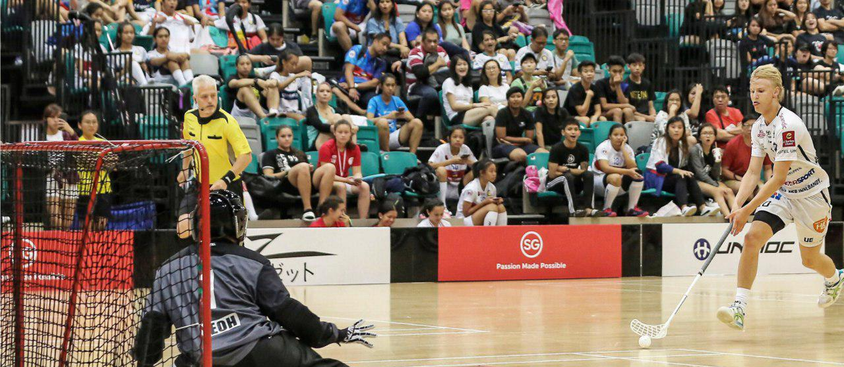
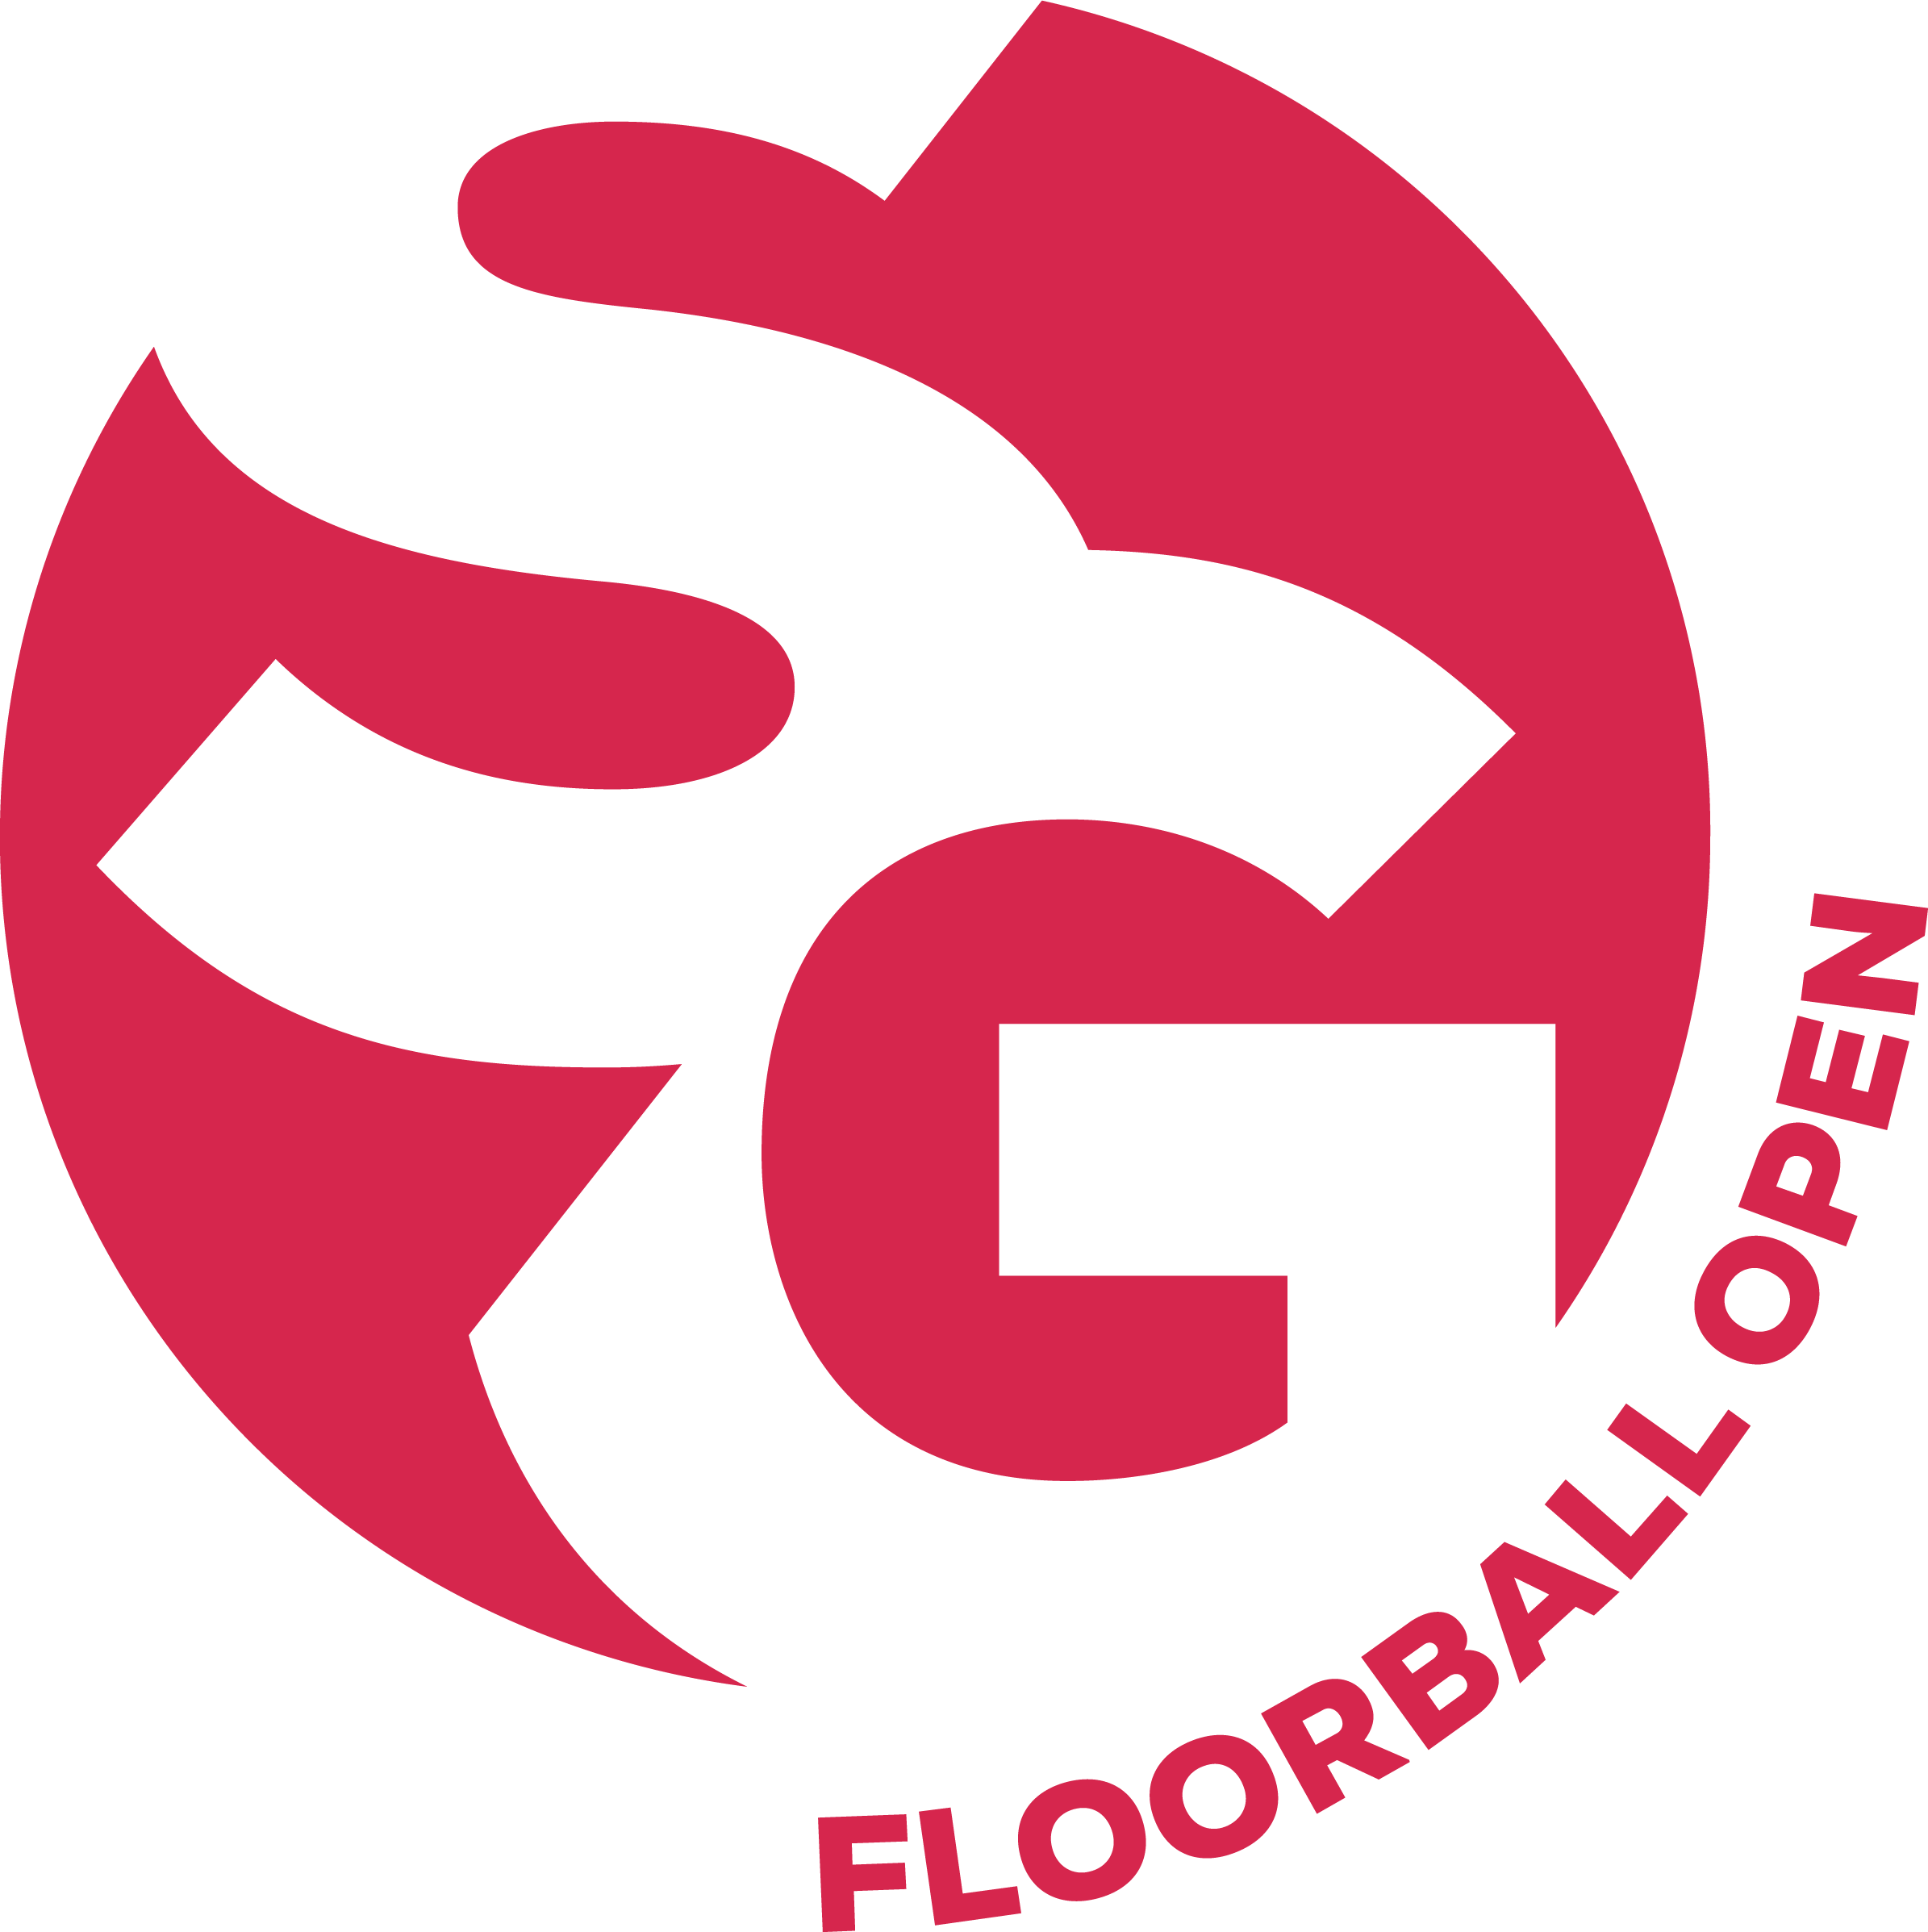
SG FLOORBALL OPEN 2024
SG FLOORBALL OPEN 2024 is not only Singapore but Asia’s biggest floorball tournament. Together with our main partners, we aim to make it the biggest tournament in the world by 2026!
SG Floorball Open; “The Singapore experience, a unique lifestyle”

Dates

4th-7th July 2024

Participation categories

ELITE

• Selected Teams from elite (1) divisions in each country

• Players must be 15 years or older (born in 2009 and older)

PRO

• Players cannot be registered in an elite division team in their respective country.

• Players must be 15 years or older (born in 2009 and older)

U-21

• For the teams with players under 21 years

• Players born between years 2003 and 2009

U-18

• For the teams with players under 18 years

• Players born between years 2006 and 2010

U-15

• For the teams with players under 15 years

• Players born between years 2009 and 2013

Who may participate?

There is a maximum of 23 players and a minimum of 6 players (5 players + 1 goalie) for a team.

It is permitted to use a player from the same club in several teams but not in the same age category. (A player can only represent one team in each age category.) This player must be on the participant list of all teams he or she will play for. The player must also be present during the age control for each team the player plays for.

All players in the ELITE categories (both Men and Ladies) category must be registered in a club as specified by IFF rules. Any player not following this rule will be penalised by awarding the game to the opposing team by default for illegal entry in the tournament.

Number of teams in the tournament

In recent years we have not been able to accept all teams that wish to participate. The teams that have registered and paid the registration fee has priority. Registration counts as the date we receive the registration fee.

When does the registration open?

The registration for SG Floorball Open 2024 opens on November 1st.

Which is the last date to register?

Deadline for making a registration is April 10th. Please note that teams who have registered and paid their registration fee first will be given priority when we reach the maximum number of teams in each category. Keep in mind that some of the categories are fully booked very early.

SG Experience Card

SG Experience Card is included for all players, leaders and accompanying families and friends who have booked their accommodation via SG Floorball Open. Accompanying families and friends who have booked their own accommodation can purchase SG Experience Card.

Transfer

Round trip transfer between the airport your accommodation is included when you purchase our tournament accommodation package with SG Floorball Open. Also included when you book your accommodation through SG Floorball Open, is one trip to and from the arena on each tournament day per team and accompanying families and friends. Transfer must be booked in advance as per specific tram information and can only be booked for minimum fifteen persons per group.

Extra nights’ accommodation for teams and accompanying families/friends

If a team need to arrive or depart outside the tournament dates, extra nights’ accommodation at special rates and can be arranged.

Age control

All participants at SG Floorball Open must complete the age control to participate in the tournament. This is to make sure that all participants are eligible to participate in the age class they are enrolled in.

Cancellation

If you need to cancel your registration, email izabela@sgopen.com and note your registration number. The registration fee is nonrefundable.
In case a player or leader must cancel the accommodation, cost is only refundable if the cancellation is made at the latest May 25th. After May 25th a doctor's notice is required to get the accommodation cost refunded.

Insurance

The team manager in charge is obligated to ensure that all participants are insured on the pitch. Each participant is responsible for his/her personal insurance off the pitch. Participants from countries that have no medical insurance agreement with Singapore must have personal medical insurance. Neither SG Floorball Open, the organisers nor the venues have collective insurance to cover injuries, illness, theft or damages.

Cancelation of the tournament and force majeure

Neither SG Floorball Open nor the organiser is responsible for compensation and they are also not responsible for financial losses or damages that may occur due to events outside the control of the SG Floorball Open or the organiser, such as war-like events, fire, flood, interruptions in public transport connections, government actions, strike or other similar circumstances.

Team Registration and Payment details

REGISTRATION OF TEAMS

SG Open regional representatives

For specific regional team registrations, there will be specific regional representatives. If there are a regional representative all teams from that region will be referred to them. All registration and accommodation as well as all communication will be from the respective regional representative.

Registration fees: (Please check social media channels for early bird offer.)
• Open S$480
• Pro S$480
• Under -21 S$380
• Under -18 S$380
• Under -15 S$380

The registration fee must be in the GED account by April 10th, 2024

• The bank charges are to be covered by the transferring team.
• The organizer has the right to exclude the team from the tournament if the registration
fee is not paid by the due day.
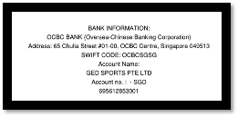
• In the case a team cancels their registration to the tournament after June 1st, 2024, the registration fee will not be refunded.

Individual fee
Any team that does not accept any of the accommodation alternatives offered by the organizer is obligated to pay the individual fee, S$55 per person for each member of the team. The fee includes the Team level SG Experience card level and all its benefits. (Not Applicable for Southeast Asia teams. Teams from SEA, please contact Izabela at izabela@sgopen.com directly for more information.).

• April 10 -deadline for registration and registration fee payments as well as lodging arrangements transferred

• June 1 – deadline for digitally send the team list for the match record to Sg Floorball Open

• June 21 - publishing the final game schedule at our website www.sgopen.com
• July 3 - official arrival day, final team registration

• July 4 - the 1st tournament day – group matches

• July 7 - the final tournament day – final matches

Email: izabela@sgopen.com
Please visit: www.sgopen.com
Instagram
Youtube
Facebook

